# CU06997 Fluid Dynamics / CU03287 Waterstroming: formulas

Henk Massink , 31-1-2014

Contents

CU06997 Fluid Dynamics / CU03287 Waterstroming: formulas 1

Principal symbols / units 2

Fluid statics 3

Visualisation flow, streamlines, streaklines, streamtube 4

Total Head or Bernoulli’s Equation 4

Turbulent and Laminar flow, Reynolds Number 6

Laminar flow in pipes and closed conduits 7

Turbulent flow in pipes and closed conduits 7

Frictional head losses 7

Local head losses 9

Partially full pipes 11

Culverts 11

Open channel flow 13

Frictional head losses, turbulent flow 13

Subcritical and Supercritical flow 15

Hydraulic structures 16

Sewers 17

# Principal symbols / units

$A=$ Wetted Area [m2] Natte doorsnede  
 Cross-sectional area of flow

b = width [m] Breedte

C = Chézy coefficient [m1/2/s] Coefficient van Chezy

$C_{v}=$ velocity coefficient [-] Snelheidscoëfficiënt $C_{c}=$ 
 contraction coefficient [-] Contractiecoëfficiënt

d, D = diameter [m] Diameter

Dm = Hydraulic mean depth [m] Gemiddelde hydraulische diepte

E = Energy [J] =[Nm] Energie

Es = specific energy [m] Specifieke energie

F = Force [N] Kracht

Fr = Froude Number [-] Getal van Froude

g = gravitational acceleration [m/s2] Valversnelling

H = head [m] Energiehoogte

hf , ∆H = frictional head loss [m] Energieverlies tgv wrijving

hL = local head loss [m] Lokaal energieverlies

kL = local loss coefficient [-] Lokaal energieverlies coëfficiënt

kS = surface roughness [m] Wandruwheid

L = length [m] Lengte

m = mass [kg] Massa

n = Manning’s roughness coefficient [s/m1/3] Coëfficiënt van manning

p* = piezometric pressure [N/m2]= [Pa] Piezometrische druk

p = pressure [N/m2] Druk

P = wetted perimeter [m] Natte omtrek

Ps = crest height [m] Stuwhoogte

Q = discharge, flow rate [m3/s] Debiet, afvoer

q = discharge per unit channel width [m3/ms] Debiet per m breedte

R, r = radius [m] Straal

R = Hydraulic radius [m] Hydraulische straal

Re = Reynolds Number [-] Getal van Reynolds

Sc = slope of channel bed to give critical flow [-] Bodemverhang voor grenssnelheid

Sf ,I = slope of hydraulic gradient [-] Energieverhang

S0 = slope of channel bed [-] Bodemverhang

Ss = slope of water surface [-] Drukverhang, verhang water

u,v = velocity [m/s] Stroomsnelheid

V = mean velocity [m/s] Gemiddelde stroomsnelheid

V = volume [m3] Volume

ū = average velocity [m/s] Gemiddelde stroomsnelheid

y = water depth [m] Waterdiepte

yc = critical depth [m] Kritische waterdiepte

yn = normal depth [m] Normale waterdiepte

z = height above datum, potential head [m] Afstandshoogte

δ = boundary layer thickness [m] Dikte grenslaag

λ = friction factor [m] Wrijvingsfaktor

µ = absolute viscosity [kg/ms]=[N s/m2] Absolute viscositeit

ν = kinematic viscosity [m2/s] Kinematische viscositeit

ρ = density of liquid [kg/m3] Soortelijk gewicht

τ0 = shear stress at solid boundary [N/m2] Schuifspanning  
ξ = (ksie) Loss coefficient [1] Verliescoëfficiënt  
µ = contraction coefficient [1] Contractiecoëfficiënt

# Fluid statics

General pressure intensity $p=\frac{F}{A}$

$p=$ Pressure [Pa=N/m2]  
 Force [N] $A=$ 
 Area on which the force acts [m2]

Newton Force $F=m∙g$

$F=$ Force [N] $m=$ 
 Weight [Kg] $g=$ 
 earths gravity [m/s2]

Fluid Pressure at a point $p=\frac{F}{A}=\frac{ρ∙g∙A∙y}{A}=ρ∙g∙y$

Pressure Head $y=\frac{p}{ρ∙g}$

$p=$ Pressure [Pa=N/m2]  
 fluid density [Kg/m3]  
 earths gravity [m/s2]  
 distance surface to point [m]

[Kg/m3]  
 [Kg/m3]

Potential Head $z$

$z=$ height above datum [m]

Piezometric Head $z_{1}+y_{1}=z_{2}+y_{2}$

$z=$ height above datum [m] $y=$ 
 distance surface to point [m]

Velocity Head $\frac{u^{2}}{2∙g}$

$u=$ Fluid Velocity [m/s] $g=$ 
 earths gravity [m/s2]

# Visualisation flow, streamlines, streaklines, streamtube

Flow rate / Discharge $Q=u∙A$

$Q=$ Flow rate [m3/s]  
 Fluid Velocity [m/s]  
 Wetted Area [m2]

Wetted Area of a filled pipe   
 Wetted Area [m2]  
 Diameter pipe [m2]

Continuity equation $u_{1}∙A_{1}=u_{2}∙A_{2}=u_{3}∙A_{3}=constant$  
(Principle of conservation of mass)

# Total Head or Bernoulli’s Equation

Total Head / Energy [m] $H=y+z+\frac{u^{2}}{2∙g}$

$y=\frac{p}{ρ∙g}=$ Pressure Head [m] $z=$ 
 Potential Head [m] $\frac{u_{}^{2}}{2g}=$ 
 Velocity Head [m]

Bernoulli’s Equation without head loss

$$y_{1}+z_{1}+\frac{u_{1}^{2}}{2g}=y_{2}+z_{2}+\frac{u_{2}^{2}}{2g}=H=constant$$

Bernoulli’s Equation with head loss

$$y_{1}+z_{1}+\frac{u_{1}^{2}}{2g}=y_{2}+z_{2}+\frac{u_{2}^{2}}{2g}+{∆H}_{1-2}$$

$y=\frac{p}{ρ∙g}=$ Pressure Head [m] $z=$ 
 Potential Head [m] $\frac{u_{}^{2}}{2g}=$ 
 Velocity Head [m] $∆H=$ 
 Head Loss [m] $g=$ 
 earths gravity [m/s2]

Momentum equation $F_{x}=ρ∙Q\left(V_{2x}-V_{1x}\right)$

$F=$ Force [N] $ρ=$ 
 fluid density [Kg/m3]  
 Flow rate [m3/s]  
 Mean velocity before [m/s] $V_{2}=$ 
 Mean velocity after [m/s]

Pitot $u=\sqrt[2]{2g∙h}$

$u=$ Fluid Velocity [m/s] $g=$ 
 earths gravity [m/s2]  
 Difference in pressure [m]

Discharge small orifice $Q=C_{v}∙C_{c}∙A_{0}∙\sqrt[2]{2g∙h}$

$Q=$ Flow rate [m3/s]  
 Wetted Area [m2]  
 velocity coefficient (0,97-0,99) [-] $C_{c}=$ 
 contraction coefficient (0,61-0,66) [-] $g=$ 
 earths gravity [m/s2]  
 Difference in pressure [m]  
Discharge large orifice $Q=\frac{2}{3}∙b∙\sqrt[2]{2g∙(h_{2}^{\frac{3}{2}}-h_{1}^{\frac{3}{2}})}$

$Q=$ Flow rate [m3/s]  
 Width orifice [m2]  
 earths gravity [m/s2]  
 Difference in pressure from top [m] $h_{2}=$ 
 Difference in pressure from bottom [m]

# Turbulent and Laminar flow, Reynolds Number

Kinematic viscosity $υ=\frac{μ}{ρ}$

$μ=$ Absolute viscosity [kg/ms] $υ=$  
 Kinematic viscosity [m2/s] water, 20°C=   
 Density of liquid [kg/m3]

Reynolds Number

Kinematic viscosity [m2/s] water, 20°C=   
 Density of liquid [kg/m3]   
 Mean velocity [m/s]  
R = Hydraulic Radius = D/4 [m] $Re=$ 
 Reynolds Number [1]

$Re>4000$ Turbulent flow $Re<2000$ 
Laminar flow

Hydraulic Radius $R=\frac{A}{P}$

$R=$ Hydraulic Radius [m] $A=$ 
 Wetted Area [m2]  
 Wetter Perimeter [m]

Hydraulic radius of a filled pipe $R=\frac{A}{P}=\frac{\frac{1}{4}∙π∙D^{2}}{π∙D}=\frac{1}{4}∙D \left[m\right]$

Hydraulic radius of a 50% filled pipe $R=\frac{A}{P}=\frac{\frac{1}{2}}{\frac{1}{2}}∙\frac{\frac{1}{4}∙π∙D^{2}}{π∙D}=\frac{1}{4}∙D \left[m\right]$

Hydraulic Diameter $D=4∙R$

$R=$ Hydraulic Radius [m] $D=$ 
 Hydraulic Diameter [m]

# Laminar flow in pipes and closed conduits

Frictional head loss (laminar flow) $h_{f}=\frac{32∙μ∙L∙V}{ρ∙g∙D^{2}}$

$h_{f}$ = frictional head loss [m] $μ=$ Absolute viscosity [kg/ms] $L=$  
 Length between the Head Loss [m] $V=$ 
 mean velocity [m/s]  
D = Hydraulic Diameter [m] $ρ=$ 
 Density of liquid [kg/m3]   
 earths gravity [m/s2]

Wall shear stress (laminar flow)

τ0 = shear stress at solid boundary [N/m2]  
 Absolute viscosity [kg/ms] $V=$  
 mean velocity [m/s] $R=$ Hydraulic Radius [m]

# Turbulent flow in pipes and closed conduits

Head loss / Energy loss $∆H=ξ∙\frac{u^{2}}{2g}$

$∆H=$ Head Loss [m] $\frac{u^{2}}{2g}=$  
 Velocity Head [m] $ξ=$ 
 Loss coefficient [1] $g=$ 
 earths gravity [m/s2]

## Frictional head losses

Darcy-Weisbach $∆H_{f}=λ∙\frac{L}{D}∙\frac{u^{2}}{2g}= ξ_{f}∙\frac{u^{2}}{2g}$

$∆H_{f}=$ Head Loss due to friction [m] $λ=$  
 Friction coefficient [1] $\frac{u^{2}}{2g}=$ 
 Velocity Head [m]  
D = Hydraulic Diameter 4R [m] $L=$ 
 Length between the Head Loss [m] $g=$ 
 earths gravity [m/s2]

Colebrook-White transition formula $\frac{1}{\sqrt{λ}}=-2log\left(\frac{k_{s}}{3,70∙D}+\frac{2,51}{Re∙{\sqrt{λ}}}\right)$

$λ=$ Friction coefficient [1]  
D = Hydraulic Diameter [m]  
*k*S = surface roughness [m]

Colebrook-White and Darcy Weisbach

$V=-2\sqrt{2g∙D{∙S}_{f}}∙log\left(\frac{k_{s}}{3,70∙D}+\frac{2,51∙υ}{D{\sqrt{2g∙D{∙S}_{f}}}}\right)$ with $S_{f}=\frac{h_{f}}{L}$

$V=$ mean velocity [m/s]

D = Hydraulic Diameter [m]  
*k*S = surface roughness [m] $υ=$ Kinematic viscosity [kg/ms] water, 20°C= $1,00∙{10}^{-6}$  
Sf = slope of hydraulic gradient [-]

*hf* = frictional head loss [m] $L=$ Length between the Head Loss [m] $g=$ 
 earths gravity [m/s2]

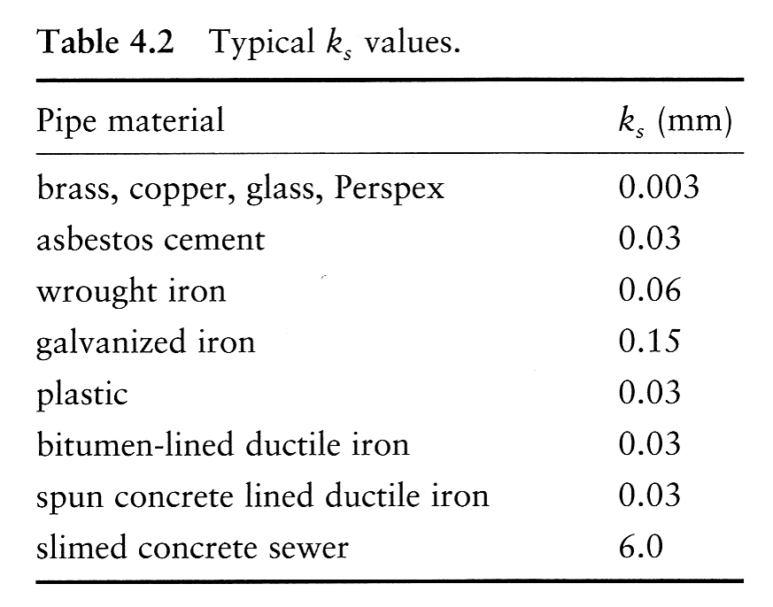

## Local head losses

Sudden Pipe Enlargement $∆H_{l}=\frac{{(V_{1}-V_{2})}^{2}}{2g}$ ${∆H}_{l}={(1-\frac{A_{1}}{A_{2}})}^{2}∙\frac{V_{1}^{2}}{2g}$ $ξ_{l}={(1-\frac{A_{1}}{A_{2}})}^{2}$

$∆H_{l}=$ Head Loss due to sudden pipe enlargement [m] $ξ_{l}=$  
 Loss coefficient due to sudden pipe enlargement [1] $A=$ 
 Wetted Area [m2]  
 Mean Fluid Velocity [m/s]  
 earths gravity [m/s2]  
1= Before enlargement  
2= After enlargement

Sudden Pipe Contraction ${∆H}_{l}={(\frac{A_{1}}{A_{2}}-1)}^{2}∙\frac{V_{2}^{2}}{2g}$ $A_{1}≅0,6∙A_{2}$

$${∆H}_{l}=0,44∙\frac{V_{2}^{2}}{2g}$$

$∆H_{l}=$ Head Loss due to sudden pipe contraction [m] $V_{}=$  
 Mean Fluid Velocity after sudden pipe contraction [m/s] $g=$  
 earths gravity [m/s2]

Tapered Pipe Enlargement $ξ_{t}=n∙{(\frac{A_{1}}{A_{2}}-1)}^{2}$

$∆H_{t}=$ Head Loss due to tapered pipe enlargement [m] $ξ_{s}=$  
 Loss coefficient due to tapered pipe enlargement [1] $A=$ 
 Wetted Area [m2]  
1= Before enlargement  
2= After enlargement $n=$ 
 factor which depends on the widening angel α  
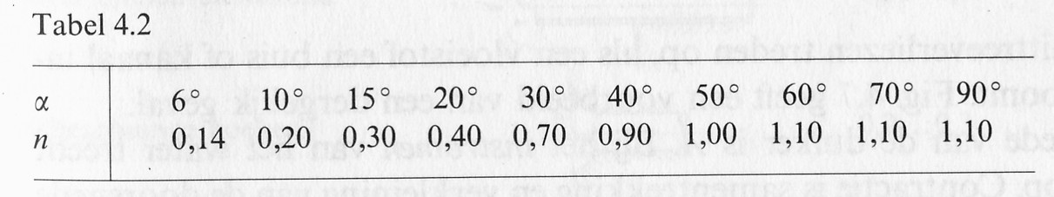

Submerged Pipe Outlet $∆H_{o}=1∙\frac{{v_{1}}^{2}}{2g}$

$∆H_{o}=$ Head Loss due to submerged pipe outlet [m] $v_{1}=$  
 Mean Fluid Velocity before pipe outlet [m/s] $ξ_{o}=1$  
 Loss coefficient due to submerged pipe outlet [1] $g=$ 
 earths gravity [m/s2]

Pipe Bends $∆H_{b}=ξ_{b}∙\frac{v^{2}}{2g}$

$∆H_{b}=$ Head Loss due to pipe bend [m] $v_{}=$  
 Mean Fluid Velocity [m/s] $ξ_{b}=$  
 Loss coefficient due to pipe bend [1] $g=$ 
 earths gravity [m/s2]

|  |  |
| --- | --- |
| D:\CourseVloeistofmechanica\Lesblok 6 en 7\fig4.10.jpg | Tabel 4.5 only applies for α = 90o and a smooth pipe.  With α = 90o and a rough pipe, increase ξ with 100%  With α = 45o use 75% ξ900  With α = 22,5o use 50% ξ900  Smooth and rough pipes are explained further on. |

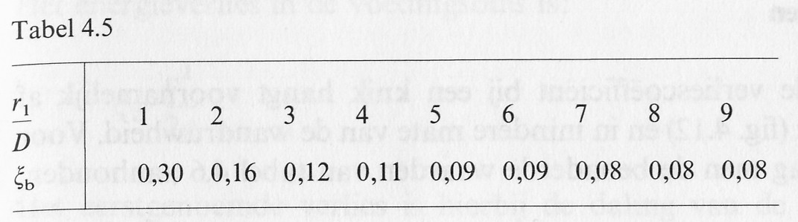

## Partially full pipes

$$A_{p }\left(h\right)=\frac{1}{4}∙D^{2}∙arccos⁡(1-\frac{2∙h}{D})-(\frac{D}{2}-h)∙\sqrt[2]{h∙D-h^{2}}$$

$$R_{p}\left(h\right)=\frac{\frac{1}{4}∙D^{2}∙\arccos\left(1-\frac{2∙h}{D}\right)}{\sqrt[2]{h∙D-h^{2}}}-\left(\frac{D}{2}-h\right)$$

$A_{p}=$ Wetted Area partially filled pipe [m2]  
 Hydraulic radius partially filled pipe [m]  
h = water level partially filled pipe [m]  
D = Diameter pipe [m]

## Culverts

Culvert submerged 1   
   
   
   
 

$∆H_{tot}=$ Total Head Loss Culvert [m] $ξ_{tot}=$  
 Sum of Loss coefficients [1] $v_{c}=$ 
 Mean Fluid Velocity Culvert [m/s] $ξ_{i}=$  
 Loss coefficient due to contraction [1] $ξ_{w}=$ 
 Loss coefficient due to friction [1] $ξ_{o}=$ 
 Loss coefficient due to outlet [1] $μ=$ 
 Contraction coefficient [1] $g=$ 
 earths gravity [m/s2]  
 Friction coefficient [1] $R=$ 
 Hydraulic Radius [m] $l=$ 
 Length between the Head Loss [m]

Culvert submerged 2 $q=$  
   
 Flow rate Culvert [m3/s]  
 Discharge coefficient [m] $A=$ 
 Wetted Area Culvert [m2]  
 Total Head Loss Culvert [m] $ξ_{tot}=$  
 Sum of Loss coefficients [1] $g=$ 
 earths gravity [m/s2]

Culvert partly submerged

**Free flow broad crested weir**  
(Volkomen lange overlaat)   
 

$q=$ Discharge Culvert [m3/s] $b=$ 
 Width weir [m]  
cv=discharge coefficient free flow broad crested weir [m1/2/s]

$H=$ Head Loss upstream [m] $h_{3}=$  
 Water level downstream [m]

**Submerged flow broad crested weir**  
(Onvolkomen lange overlaat) $q=$  
   
   
 Discharge Culvert [m3/s] $b=$ 
 Width weir [m]  
col=discharge coefficient submerged flow broad crested weir [1] $H=$ 
 Head Loss upstream [m] $h_{3}=$  
 Water level downstream [m]

Total head (H) and water level (h) measured from crest weir (bed culvert)

# Open channel flow

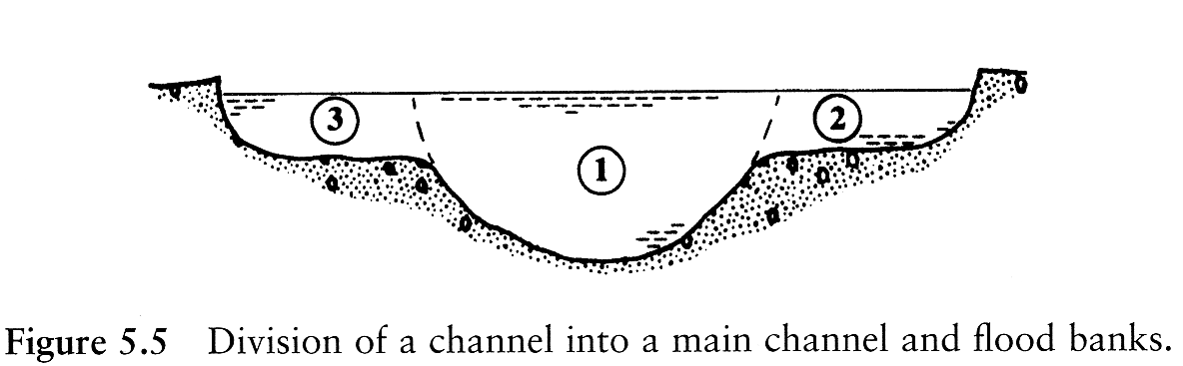

$$V_{average}=\frac{Q}{A}=\frac{V_{1}A_{1}+V_{2}A_{2}+V_{3}A_{3}}{A_{1}+A_{2}+A_{3}}$$

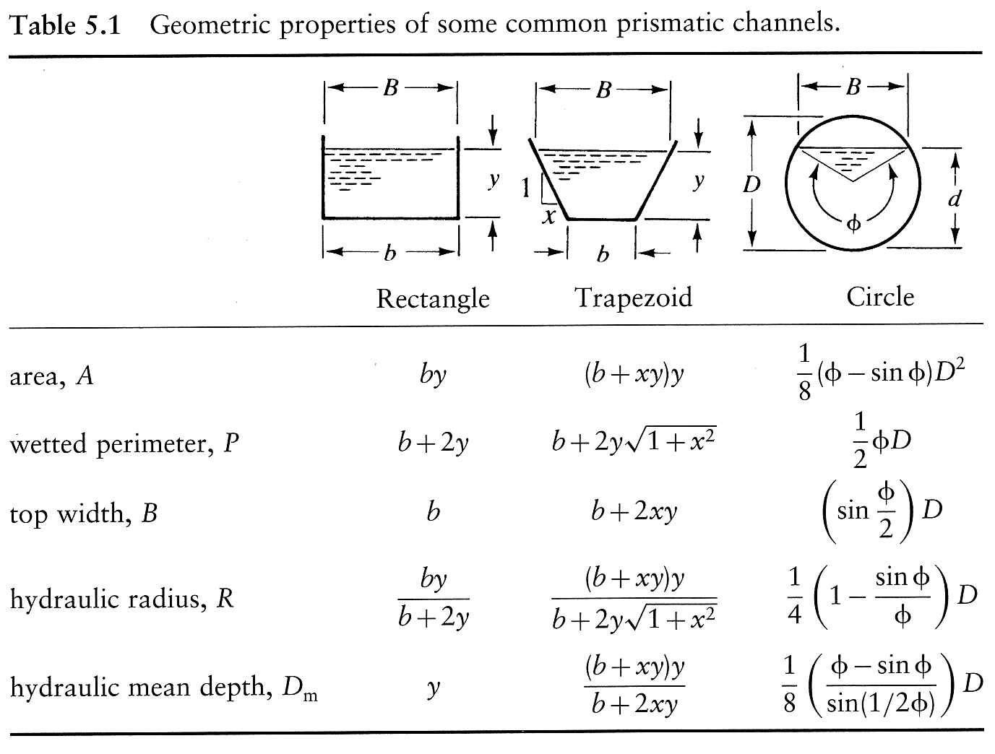

## Frictional head losses, turbulent flow

Mean boundary shear stress

τ0 = shear stress at solid boundary [N/m2]  
 Hydraulic Radius [m] $S_{0}=$ 
 Slope of channel bed [1]

Chezy $V=C∙\sqrt{R∙S_{f}}$

$V=$ Mean Fluid Velocity [m/s] $R=$ 
 Hydraulic Radius [m] $S_{f}=$ 
 Slope energy / total head [1] $C=\sqrt{\frac{8g}{λ}}$ 
 Chezy coefficient [m1/2/s]

Manning $V=\frac{R^{\frac{2}{3}}{∙S}_{f}^{\frac{1}{2}}}{n}$ $$Q=\frac{1}{n}∙\frac{A^{\frac{5}{3}}}{P^{\frac{2}{3}}}∙S_{f}^{\frac{1}{2}}$$

$V=$ Mean Fluid Velocity [m/s] $R=$ 
 Hydraulic Radius [m] $S_{f}=$ 
 Slope Total Head [1] $A=$ 
 Wetted Area [m2]  
 Wetter Perimeter [m] $n=$ 
 Mannings roughness coefficient [s/m1/3]

Specific energy $H_{s}=y+ \frac{V^{2}}{2g}$

$V=$ Mean Fluid Velocity [m/s] $y=\frac{p}{ρ∙g}=$ 
 Pressure Head / water depth [m]

Equilibrium / normal depth [m] $y_{n}=\sqrt[3]{\frac{q^{2}}{b^{2}∙C^{2}∙S_{0}}}$ $S_{0}=S_{f}$

*y*n = normal depth, equilibrium depth [m]

q = discharge [m3/s]

b = width [m]

$S_{0}=$ bed slope [1] $S_{f}=$ 
 Hydraulic gradient caused by friction [1] $C=\sqrt{\frac{8g}{λ}}$ 
 Chezy coefficient [m1/2/s]

Backwater, direct step method $∆x=∆y∙(\frac{1-{Fr}^{2}}{S_{0}-S_{f}})$

Δx= horizontal distance from point [m]

Δy= waterdepth [m]

Fr = Froude number [-]

$S_{0}=$ bed slope [1] $S_{f}=$ 
 Hydraulic gradient caused by friction [1]

## Subcritical and Supercritical flow

Critical depth [m] $y_{c}=\sqrt[3]{\frac{Q^{2}}{g∙B^{2}}}$

Critical velocity [m/s] $V_{c}=\sqrt[2]{g∙y_{c}}$

Froude Number $Fr=\frac{V}{\sqrt[2]{g{∙y}_{c}}}=\frac{V}{V_{c}}$

*y*c = critical depth [m]

Q = discharge [m3/s]

B = width [m]

*V*c = critical velocity [m/s]

*V* = actual velocity [m/s]

Fr = Froude number [-]

**Subcritical flow** Fr < 1 V < Vc

**Supercritical flow** Fr > 1 V > Vc

Energy loss hydraulic jump $∆E=\frac{{(y_{2}-y_{1})}^{3}}{4∙y_{1}∙y_{2}}$

ΔH = Energy loss hydraulic jump [m]  
*y*1= depth supercritical flow [m]

*Y*2= depth subcritical flow [m]

Critical bed slope $S_{c}=\frac{g∙n^{2}}{y_{c}^{\frac{1}{3}}}$

*S*c = critical bed slope [-]

*y*c = critical depth [m]

$n=$ Mannings roughness coefficient [s/m1/3]

## Hydraulic structures

Thin plate (sharp crested weirs) $Q_{ideal}=\frac{2}{3}∙b∙\sqrt[2]{2g∙h_{1}^{\frac{3}{2}}}$

Rehbock formula Q $=\frac{2}{3}∙\sqrt[2]{2g∙(0.602+0.083∙\frac{h_{1}}{P_{s}})∙b∙{(h_{1}+0.0012)}^{\frac{3}{2}}}$ $$30mm<h_{1}<750 mm, b>300 mm, P_{s}>100 mm, h_{1}<P_{s}$$

Q = discharge [m3/s]

b = width [m] *h1* = pressure above crest [m]

*Ps* = crest height [m]

Vee weirs $Q=C_{d}∙\frac{8}{15}∙\sqrt[2]{2g∙tan⁡(\frac{θ}{2})∙h_{1}^{\frac{5}{2}}}$

Q = discharge [m3/s]

discharge coefficient [-] θ=90°, Cd=0.59

*h1* = pressure above crest [m]

θ = angle vee [°]

Rectangular broad crested weir $Q_{ideal}=1.705∙b∙H_{1}^{\frac{3}{2}}$

Ackers $C_{f}≅0.91+0.21∙\frac{h_{1}}{L}+0.24∙\left(\frac{h_{1}}{h_{1}+P_{s}}-0.35\right)$

$$0.45<\frac{h_{1}}{L}<0.8, 0.35<\frac{h_{1}}{h_{1}+P_{s}}<0.6$$

Q = discharge [m3/s]

b = width [m] *h1* = pressure above crest [m]

*Ps* = crest height [m]

L = length weir [m]

Cf = friction coefficient [-]

Discharge broad-crested weir $Q=C_{d}∙C_{v}∙\frac{2}{3}∙\sqrt[2]{\frac{2g}{3}∙b∙h^{\frac{3}{2}}}$

Q = discharge [m3/s]

b = width [m] $C_{v}=$ velocity coefficient ) [-] $C_{d}=$ 
 discharge coefficient [-]

h = water pressure above crest [m]

Venturi flume $Q=1.705∙b_{2}∙C_{d}∙C_{v}{∙y}_{1}^{\frac{3}{2}}$

Q = discharge [m3/s]

b = width [m]   
 velocity coefficient ) [-]  
 discharge coefficient [-]

*y1* = pressure above crest [m]

# Sewers

Filled pipes $∆H=L∙\frac{Q^{2}}{C^{2}∙R∙A_{}^{2}}$

$∆H=$ Head Loss, energy loss [m]

Q = discharge pipe [m3/s]

L = length of the pipe [m]

$C=$ Chezy coefficient [m1/2/s] $R=$ 
 Hydraulic Radius [m] $A=$ 
 Wetted Area, flow surface [m2]  
Chezy coefficient $C=18∙log\left[\frac{12R}{k}\right]$

$C=$ Chezy coefficient [m1/2/s] $R=$ 
 Hydraulic Radius [m]  
*k*S = surface roughness [m]

Energy Gradient [-] $S_{f}=i=\frac{∆H}{L}$

Sf ,i = slope of hydraulic gradient [-]

L = length [m]

$∆H=$ Head Loss, energy loss [m]

Overflow / weir sewer $Q=m∙B∙H^{\frac{3}{2}}$

Q = discharge overflow [m3/s]

m = runoff coefficient (1,5 – 1,8) [m1/2/s]

B = Width crest overflow [m]

H = Head at overflow [m]  
 measured from top crest!!